|  |  |  |  |  |  |
| --- | --- | --- | --- | --- | --- |
| **Module No:** | 1 | **IU No:** | 3 | **Exercise No.** | 3 |

|  |  |
| --- | --- |
| **Lab Assessment Statement** | **Assignment 3 – Implement O Auth Integration for SignUp**  **Referring to Assignment-1's Project Scenario,**  The scope of this assignment is to implement O Auth Integration for SignUp using Facebook for ‘XYZ Cars Pte Ltd’.  These are the steps provided to build an API.   1. Create developers Account on Facebook 2. Create New Application for using social integration. 3. Implement Social login using Facebook in XYZ cars Portal. 4. Use created App Id and App Secret in Application. 5. Login using Facebook.   **Provide the source code of developed application.**  **Provide screen capture of final result pages for API testing.** |
| **Technical Environment** | - Spring Boot, Facebook API Integration |
| **Guidelines** | - |
| **Duration** | 120 mins |

**Solution :**

1. **Create developers Account on Facebook**

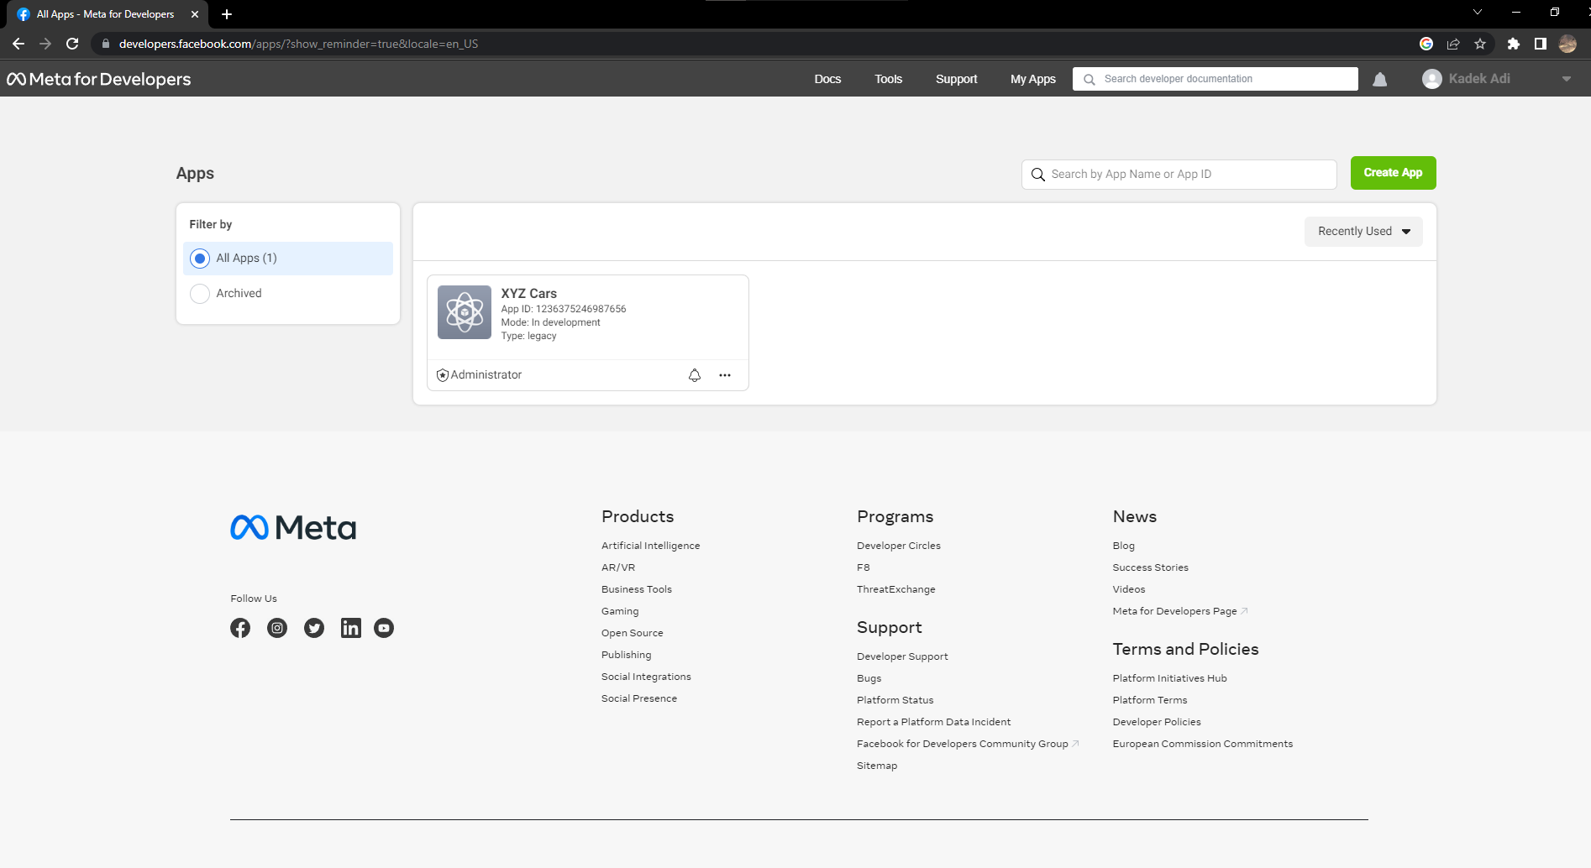

1. **Create New Application for using social integration.**

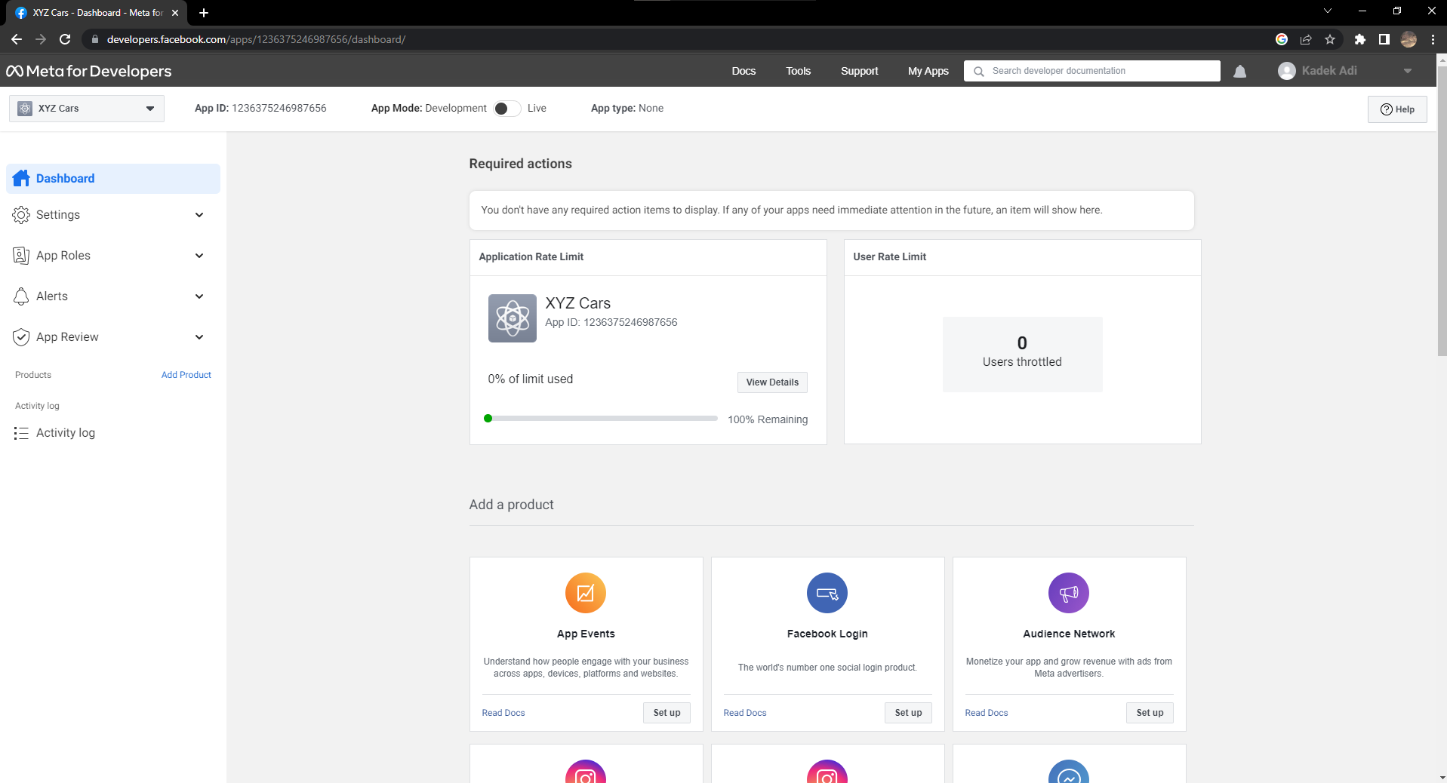

1. **Implement Social login using Facebook in XYZ cars Portal.**

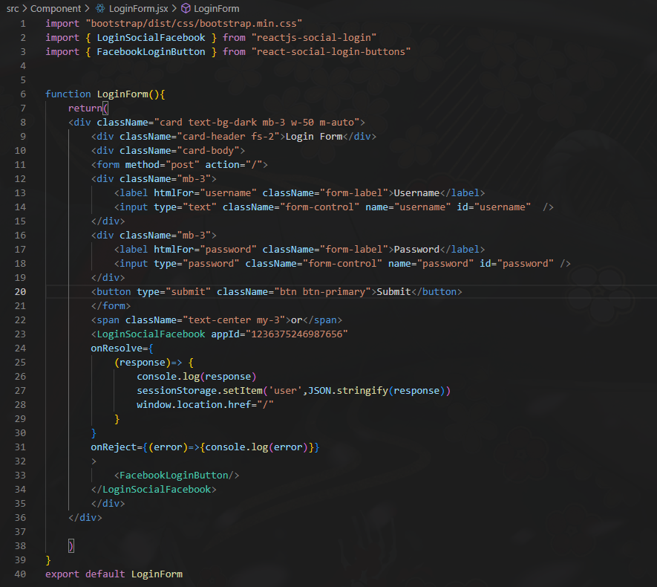

1. **Use created App Id and App Secret in Application.**

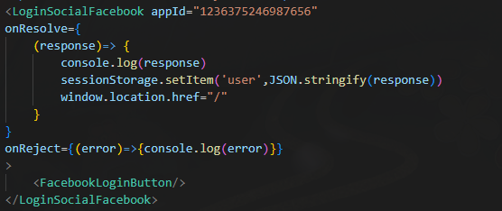

1. **Login using Facebook.**

